School Emblem | School Name
School Emblem | Title of Research
School Emblem | SDGs Aspects：⬜Social Progress⬜Environmental Protection⬜Economic Growth
School Emblem | Instructor’s Name
School Emblem | Students’ Names

- Topic Overview:
Please provide a brief summary of the chosen topic, highlighting its significance and specific goals you aim to achieve.

- Exploration Process:
- I Idea Generation and Selection:
Please explain how you developed and finalized your exploration topic.
- Description of the Exploration Process:
Please outline the step-by-step process you followed during exploration, including research, data collection, experiments, or any other relevant activities undertaken.
- Challenges Encountered:
Please discuss the challenges you faced during exploration, such as limited resources, time constraints, or technical difficulties.
- Problem-Solving Journey:
Please share how you overcame the challenges encountered during the exploration process. This section will highlight your problem-solving strategies, innovative approaches, or collaborations that helped you overcome obstacles.
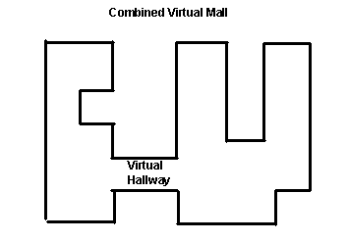
Figure 1. Insert caption to place caption below figure.

.

Table 1. Table captions should be placed above the table
Graphics | Top | In-between | Bottom
Tables | End | Last | First
Figures | Good | Similar | Very well

- Learning Outcomes:
- Description of Outcomes:
Please present a comprehensive description of your learning outcomes, explaining the findings or solutions you obtained through exploration.
- Things Worth Sharing:
Please highlight specific aspects of your learning outcomes that you believe are worth sharing, such as innovative ideas, unique approaches, or significant contributions to the chosen topic.

- Reflection:
- Areas for Improvement:
Reflect on the exploration process and identify areas that could be improved. This may include modifications to methodology, data analysis, or other aspects of the exploration.
- Potential Extensions:
Discuss areas within your topic that could be further explored or expanded upon.
- Relevance to Future Exploration Topics:
Reflect on how your exploration and learning experiences have contributed to your understanding of other potential exploration topics. Discuss the knowledge, skills, or insights gained that could be applied to future exploration projects.
- References:
[1] Bowman, M., Debray, S. K., and Peterson, L. L. 1993. Reasoning about naming systems. ACM Trans. Program. Lang. Syst. 15, 5 (Nov. 1993), 795-825. DOI= http://doi.acm.org/10.1145/161468.16147.
[2] Ding, W. and Marchionini, G. 1997. A Study on Video Browsing Strategies. Technical Report. University of Maryland at College Park.

Photo | Photo | Photo
Description | Description | Description
Photo | Photo | Photo
Description | Description | Description
Link/ QR-code to Extra Materials
Attach here links or QR-codes for supporting materials or videos related to learning outcomes.

